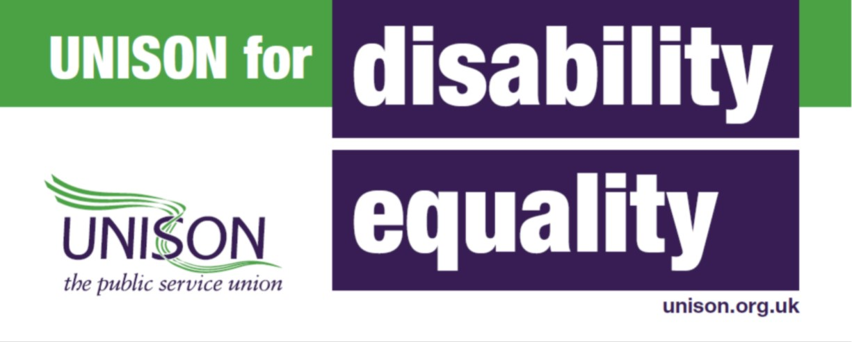

Cardiff and Vale Unison Health Branch Disabled Members officer
AGM Report 2021/2022

This has been a busy and productive year in my role as disability members officer. I have continued to help disabled members with work related disability issues.

C&V Unison Health Branch Disabled Members Self Organised Group (SOG)
Disabled workers can face disadvantages within the workplace, which has highlighted the need for individuals with impairments to have a collective voice within their workplace.
I am therefore delighted to report the launch of the Cardiff and Vale Unison Health Branch SOG. This is a member led group and I would like to encourage any members who can self-identify as having an impairment joins the SOG group. The aim of the group is to have a voice in all matters relating to disability inequalities members may face within their workplace. The SOG meets monthly (Dates of the 2022 SOG meetings will be published in a poster soon). If you require a copy of the poster, please feel free to contact me and I get one sent to you. Please feel free to display the poster in your staff room notice boards. The poster will be also be displayed in the HB’s intranet site.
Recurring reminders of SOG meetings will be sent out by the Unison office to all Unison members.
In addition, there is a ‘C&V Unison Health Branch Disabled Members’ Facebook account, this features many useful information for our disabled members. Please note, that this is a private FB group and can only be viewed by the group members.

Covid – 19 and Long - Covid

It’s a frightening statistic but disabled people are twice as likely to die from COVID-19 as non-disabled people. The risk is even higher for Black disabled people, disabled people who are pregnant and disabled workers in front line jobs. Unison has worked to ensure that the concerns of our disabled members are at the heart of our responses to the coronavirus crisis and that equality is central to our bargaining, lobbying and campaigns agenda.

As we move past more than a year since the onset Covid-19, we are seeing a rise in long-Covid related sickness absences. In particular we have seen how ‘Long Covid’ has impacted upon disabled peoples existing conditions and triggered new conditions.

“The Office for National Statistics (ONS) estimates that over a million people in the UK were reporting symptoms associated with long COVID at the beginning of March 2021… An estimated 674,000 people reported that their symptoms have negatively impacted on their ability to undertake their day-to-day activities.

The NICE (National Institute for Health and Care Excellence) guideline uses the following clinical definitions: • Acute COVID-19: signs and symptoms of COVID-19 for up to 4 weeks. • Ongoing symptomatic COVID-19: signs and symptoms of COVID-19 from 4 to 12 weeks. • Post-COVID-19 syndrome: signs and symptoms that develop
during or after an infection consistent with COVID-19, continue for more than 12 weeks and are not explained by an alternative diagnosis. • Long COVID is commonly used to describe signs and symptoms that continue or develop after acute COVID-19. It includes both ongoing symptomatic COVID-19 and post-COVID-19 syndrome.

Common symptoms of Post-Covid-19 Syndrome include (but are not limited to) fatigue, brain fog, shortness of breath, difficulty concentrating, pain and changes in mood. Symptoms can often be fluctuating which adds another layer of complexity in managing the condition both personally and within the workplace.
Some people can experience long-term organ damage including to the heart, lungs, kidneys, pancreas and liver. Post-COVID conditions also can include the longer-term effects of COVID-19 treatment or hospitalisation, including difficulties swallowing and changes to the voice, severe weakness and PTSD (post-traumatic stress disorder).

Paper payslips
Following on from a discussion at a disabled members SOG meeting. We discussed the difficulties that individuals with dyslexia experience when trying to access their payslips on ESR. Following on from the from this discussion, I met with Mike Mullan (workforce information) and Keithley Wilkinson (Equalities officer) to discuss issuing paper payslips to individuals with dyslexia that are unable to access ESR. where It was agreed that this would be accommodated on an individual request basis.
Going forward, I would like to campaign to extend this agreement to all individuals that fall within the disabilities umbrella of the Equalities act 2010. And my vision going forward is for the health board to agree this formally in a procedure document.

CD&T CB Protected Characteristic Allies
I am delighted to have been chosen for the Protected Characteristic ‘Disability ally role’, for my (CD&T) Clinical Board. This role will mirror the roles taken up by the HB’s Executive Directors, and CB’s throughout the organisation. There will be a protected characteristic ally role for each of the 9 protected characteristics that fall within the Equalities act 2010:
- Age Sex equality
- Disability Sexual orientation
- Gender reassignment Welsh Language (The Welsh Language
- Marriage and civil partnership are not part of the Equality Act as it is
- Pregnancy and maternity covered by its own specific piece of
- Race legislation, The Welsh Language
- Religion or belief measure 2011 but is no less important)

Recording disability on ESR
The UHB has 678 people (out of more than 15000 staff) that have disclosed to having a disability on ESR. This figure is far too low considering the size of our organisation and highlights the importance that staff disclose their impairments on ESR. I therefore would like to encourage any members who have a disability or can self-identify to having a disability to update their ESR status. This could be done by logging on to ESR, and following my equality & diversity - view details – update my information sections.

Disabled accessible workplaces
Following on from a discussion at a staff side meeting on a H&S inspection of a new built office where no provision was in place for a member of staff who is a wheelchair user. The new build doesn’t have a disabled accessible toilet and the only staff toilet is accessible through a kitchen area accessed via steps with no ramp facility. This is not acceptable, and considerations on accessible workplaces should be given at the onset of any planning stage.

I am delighted to announce that after raising the above issue at exec level, I have been invited to be part of the HB’s Future Hospitals team. The team is going to start working on the design principles that need to underpin the replacement of UHW (and the redevelopment of UHL) with a particular focus on what is important from patient and staff experience perspectives. Experiencing of accessing our services and how patients flow through the system / building will be a really important aspect of this. With the need of a particular focus on the experience from the perspective of disabled people, and other protected characteristic groups – for example gender neutral bathroom and toilet facilities etc.
Discussion at our Disabled Members SOG meetings around what’s important to our disabled staff, and what they would like to see in the new hospital will play a vital role in me feeding back ideas to the Future Hospitals team.

Westminster Employment Forum conference
I will be attending the Westminster Employment Forum conference (January 2022) on Disability in the workplace - inclusivity, progression, reporting and priorities for the National Disability Strategy.

The Westminster Employment Forum is strictly impartial and cross-party, and draws on the considerable support it receives from within Parliament, government and regulatory bodies.
Expected speakers will include, Members of both Houses of Parliament, senior government officials in this area of public policy, together with diversity and inclusion specialists, human resources professionals, disability rights campaigners, employment lawyers, occupational health providers, think tanks, recruitment firms, education providers, as well as researchers in academia and higher education, and reporters from the national and specialist media.

My action for 2022

Disability (reasonable adjustments) passport
Many of our members may not be receiving the reasonable adjustments they need in their workplace environment, whether it be removing physical barriers or providing additional support for a disabled employee to protect against substantial disadvantage.
A way to encourage the introduction and continuous support of reasonable adjustments, would be a disability passport document. A disability passport provides a framework for discussion with a manager and disabled employee regarding the support required for that disabled employee. This passport would remain part of the disabled employees’ employment and therefore would also provide added support when changing roles within an organisation or when a line manager changes; often a very anxious times for a disabled employee.
Unison have and other Unions, including the TUC have developed Disability Passports. I will use these models to campaign on getting UHB wide disability passport.
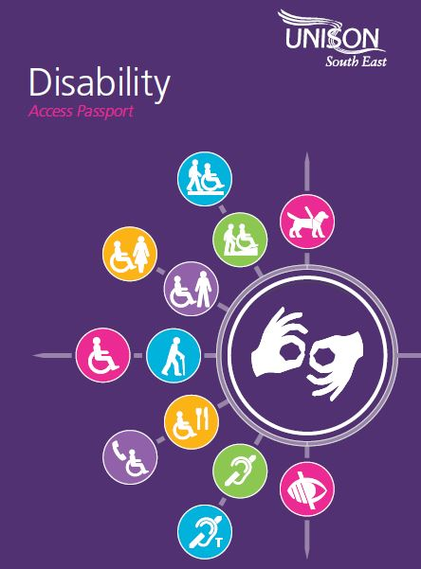
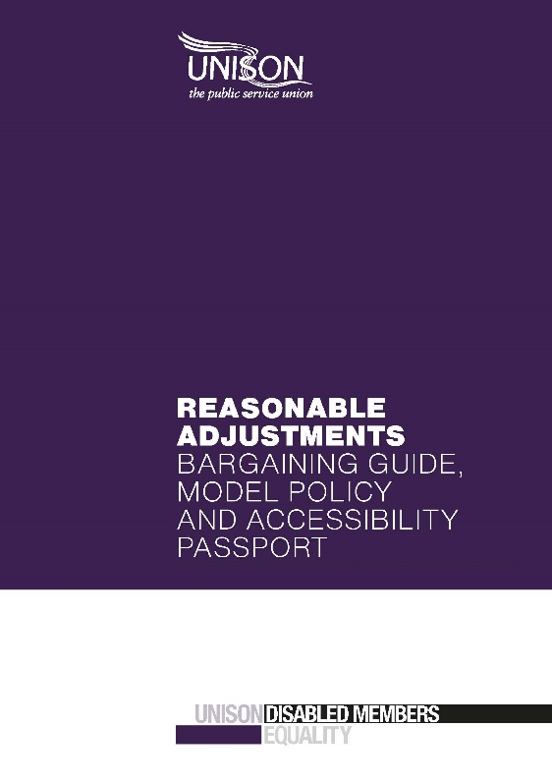

The NHS Employers have also produced a Disability passport document for individuals working in the NHS with a disability, long term health condition, mental health issue or learning disability/difficulty, and are now being used in many NHS Trusts throughout England.

