Health Conference 2022
Monday 25th - Wednesday 27th April.

Attending
Dawn Ward - Regional Chair
Roisin Kirby (Lead Delegate)
Connor Ireland (Delegate)
Jess Kelly (Delegate)
Julia Davies (Delegate)
Bill Salter & Mathew Thomas (Shared)
_______________
All Motions were around safe staffing levels staff leaving the NHS poor pay improving recruitment and retaining staff and campaigning for a decent pay rise to try and help staff who are going to struggle through this cost of inflation crises.
All motions were passed fully supported however 1 motion was split.
Motion 7 was to work with the PRB Pay review body in trying to get an improvement from them and their advice on our members pay rises as it is not working at present if this was supported then Motion 8 would fall motion 8 was from Northern Ireland and they wanted to get rid of the Pay review body.
Wales voted in favour of motion 7 as getting rid of the Pay Review Body without a plan could make things worse for future pay talks however Motion 7 states that if we fail to change the Pay Review body the union looks to get rid of it when a proper plan is in place.
The split was 50/50 and the Chairperson asked for a Card vote
The following day the result from the card vote was
Motion 7 For 207.067 Against 114.619 therefore Motion 7 was supported therefore Motion 8 fell
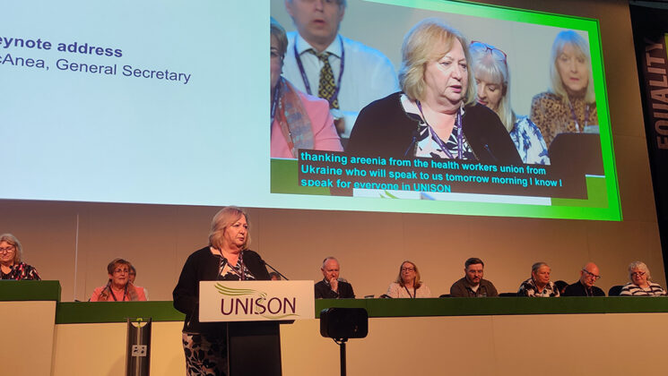
Christina McAnea brought UNISON’s health conference to its feet this afternoon, as she tore into the Westminster government’s record on funding the NHS, and on its handling of COVID-19.
“The pandemic proved just how much we all need the NHS and the incredible staff who work in it,” she said, “yet both the prime minister and the chancellor still take it for granted.”
Celebrating the work done by the whole NHS team – and the general secretary included her own recent experience of surgery – she said that the extraordinary work the NHS does is “undermined by the political choices that governments make.
“Not only do they undermine your work by underfunding the NHS, they undermine it by forcing workers into the cost of living crisis.
“And I use the word ‘forcing’ deliberately, because it’s a political choice that keeps your pay down and pushes your workloads up.
“It’s a political choice to increase National Insurance contributions for working people and to force household bills to skyrocket.
“It’s a political choice to decide not to give you and other essential workers a decent pay rise.

The Tory blame game
And on the Tory blame game, she condemned the “shameful” attempt by Conservative MP Michael Fabricant to justify the lockdown lawbreaking of the prime minister and chancellor by suggesting that health staff had done the same.
Turning to the chair of the Health Service Group Executive, she said: “The next time Roz Norman and I get to meet [Health secretary] Sajid Javid – and he has asked for a meeting – how about it Roz; you and I’ll turn up as Patsy and Eddie from Ab Fab, with a glass of champagne in our hands, saying we’ve just come from an NHS party!”
And the roars of laughter increased when she added: “Even better … we’ll take Angela Rayner with us!” in reference to the previous day’s sexist claims by anonymous Tory MPs in the Mail on Sunday, that the UNISON member and deputy leader of the Labour Party tried to upset Boris Johnson by crossing and uncrossing her legs when sitting opposite him in Parliament.
“Tory ministers have to stop watching Carry On films,” Ms McAnea added, dryly.
And Ms McAnea concluded by stressing that nobody should forget that “we are a force to be reckoned with. Don’t let anyone tell you that we’re not. Never underestimate that, conference.” The hall stood to applaud her.

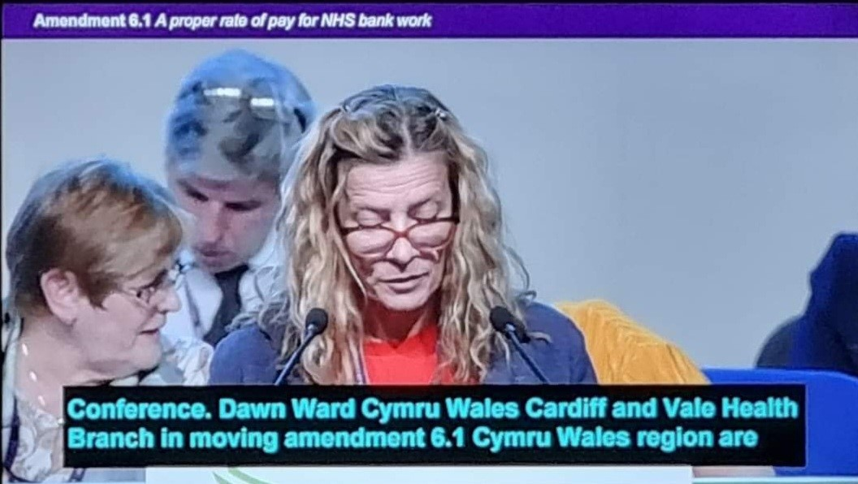

After setting out the differing context of the 2022/23 pay round in each of the four nations of the UK, they laid out the six core elements of the health service group’s pay strategy, which calls for:
- put pay right – an inflation-busting pay rise
- end poverty pay – pay higher than the real living wage to all in the NHS
- grade workers correctly for the job they do
- pay the hours people work
- fix unfinished business in the pay structure – promotions should come with pay rises
- invest in workers’ futures – and get apprentices the right pay
They also identified the longer-term goals of the service group to:
- make pay and earnings a strategic issue – not a narrow annual event
- secure more power in annual pay rise determinations
- increase participation of members so that we have a real ability to challenge outcomes
Pay outcomes 2022/23 – member consultation
The session kicked off by carrying a motion around conducting member consultations. Moving the motion, Moira McKenna, speaking on behalf of the service group executive (SGE), said: “We know the Westminster government is likely to drag its heels again this year. We hope we won’t be, but we may be waiting another three months before receiving an offer on pay.”
Ms McKenna urged conference to pass the motion, which calls on the SGE to consult members across the UK on pay, to put the service group in a strong negotiating position and give it the ability to “react as quickly as possible over the next few months,” regardless of when Westminster or the devolved governments bring offers to the table.
35-hour work week
Motion 2 called on the SGE to prepare a case for the introduction of a 35-hour work week without a reduction in pay.
Our members deserve to have a life outside of work, we deserve to ask for more, not just keep our heads above water.”

Cardiff and Vale were proud to have 2 youth delegates who were at conference Connor Ireland and Jess Kelly who were involved in the national youth health especially Connor who attended focus groups on this very motion and issue.
A motion from the national young members’ forum stressed the negative impact of the pandemic on mental health, emphasising that it is a trade union issue, with the union’s LGBT+ group adding that this impact was increased for LGBT+ people, with trans and non-binary people particularly badly affected, as attacks on that group increase.
Ben Jackson from Greater Manchester mental health spoke of his shock at the decline in mental health during the pandemic, as managers want to “place more and more work on less and less staff,” with the managers themselves under huge stress to do their jobs.
“We had eight wards over new year with no nurses,” he reported, as an indicator of the crisis facing both staff and patients.
“We, as trade unionists, are often the first point of contact for staff facing mental issues”. He said that in 26 years he had never seen such levels of pressure and stress on colleagues.
“Don’t ever under-estimate the value of the rep in supporting somebody with mental health difficulties,” he said, while adding: “Remember your limitations and refer people. And look after your own mental health too.”

Ronnie Nicholson, of the operational services occupational group, introduced a motion on fair jobs for admin staff – on what was, by happy coincidence, Admin Professionals Day.
He told delegates: “It’s not just enough to fight against attacks on jobs – some of our energy must be spent on making jobs better.”
Admin staff make the NHS effective, he added, yet “we often hear from admin staff that there is no plan for their development and career”.
Conference called on the executive to:
- lead an occupation-focused campaign to improve admin jobs, in terms of career progression and fair pay
- research the skills, knowledge and experience that are likely to be needed in the future, in order to guard against outsourcing and to help ensure the fair grading of posts.

CONFERENCE CLOSED

